1. I am now happy with the level of abstraction.

2. Something doesn’t work here, DocumentNumber is defined and somehow doesn’t work


3.
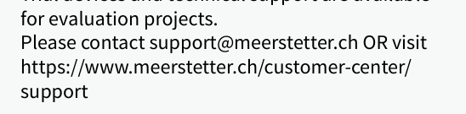Links like these are bad for disabled people and this is primarily an online document (and nobody is going to type an address from a printed datasheet, they’ll just google Meerstetter support) -> replace the link with words “or visit our support center” with hyperlink to the page on the 2 words “support center”.
OR should be written small as OR sounds aggressive.

5. 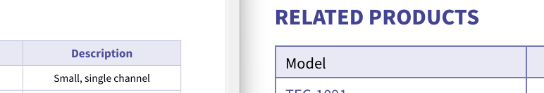
The purple header text style seems to be broken in the table headers (left: the mockup, right: your file)

6. Spelling mistake:

7.
Replace meerstetter’s with Meerstetter Engineering as that is the company name

8. I see a lot overfull unterfull warnings with badness 10000. This is apparently not good. If it cannot be avoided, I’m ok with it.
You can probably fix this.

9. Ordering code table: Please change the structure and design as follows:
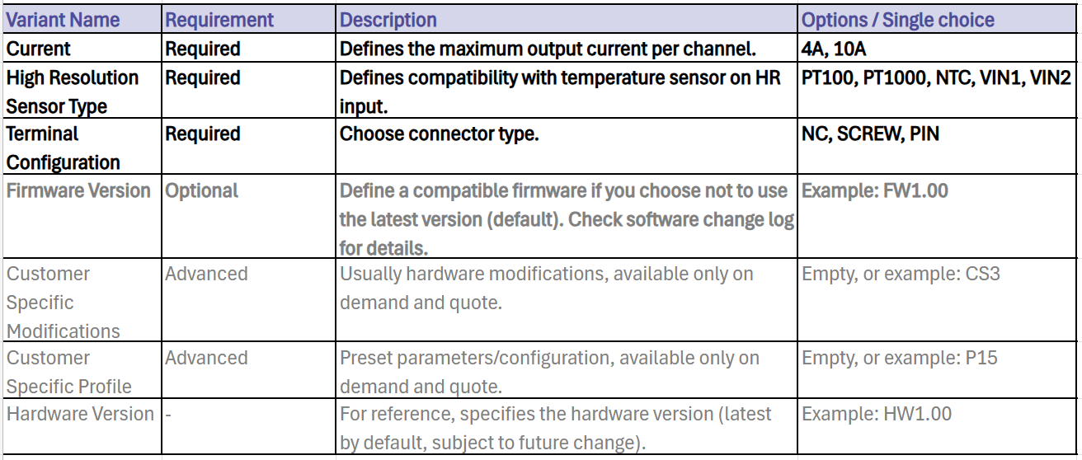
- Variant name and Requirement: Change columns
- Required rows: Bold
- Firmware row: Bold, grey color
- Other rows: grey color

